Azure - Storage

he Storage component of Windows Azure represents a durable store in the cloud. Windows Azure allows developers to store tables, blobs, and message queues. The storage can be accessed through HTTP. You can also create our own client; although Windows Azure SDK provides a client library for accessing the Storage.

In this chapter, we will learn how to create a Windows Azure Storage account and use it for storing data.

## Creating Azure Storage Account

**Step 1** − When you login into your Azure account, you can find ‘Storage’ under ‘Data Services’.

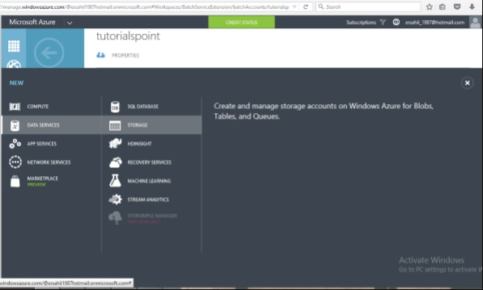

**Step 2** − Click on ‘Quick Create’ and it will ask for ‘Account Name’.

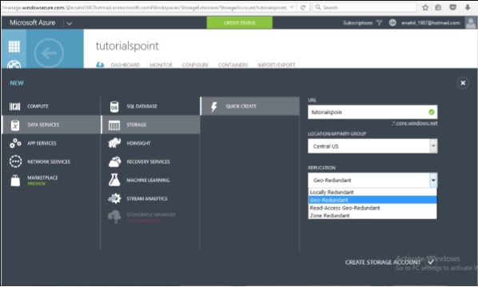

You can see there are four options in the ‘Replication’ dropdown. A copy of the data is kept so that it is durable and available at high speed. It is retained even in case of hardware failure. Let’s see what these options mean −

* **Locally redundant storage** − Copy of the data is created in the same region where storage account is created. There are 3 copies of each request made against the data that resides on separate domains.
* **Zone-redundant storage (available for blobs only)** − Copy of the data is created on separate facilities either in the same region or across two regions. The advantage is that even if there is failure on one facility, the data still can be retained. Three copies of data are created. One more advantage is that data can be read from a secondary location.
* **Geo-redundant storage** − `Copy is created in a different region which means data is retained even if there is a failure in the complete region. The numbers of copies of data created are 6 in this case.
* **Read-access geo-redundant storage** − This option allows reading of data from a secondary location when data on the primary location is not available. The number of copies created is 6. The main advantage here is that availability of data can be maximized.

There are different price plans for each replication option and the ‘Local Redundant’ is the cheapest of them all. So, choosing the replication of data depends on the cost and individual requirements.

## Storage Account Ends

**Step 1** − Click on the ‘Storage Account’ it will take you to the next screen.

**Step 2** − Click on ‘Dashboard’ from top horizontal menu.

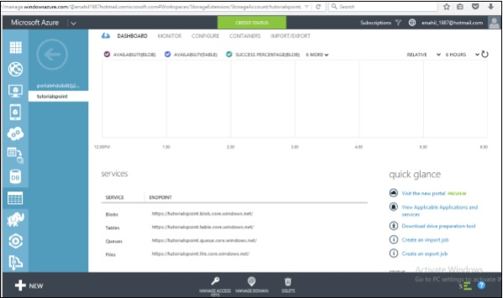

Here you can see four items under services. You can create blobs, tables, queues and files in this storage account.

There will a unique URL for each object. For example, here account name is ‘tutorials’ then the default URL for blob is **https://tutorials.blob.core.windows.net** Similarly, replace blob with table, queue and file in the URL to get the respective URLs. To access an object in the location is appended in the URL. For example,**http://tutorials.blob.core.windows.net/container1/blob1**

## Generating an Access Key

Access key is used to authenticate the access to the storage account. Two access keys are provided in order to access the account without interrupting it, in case, one key has to be regenerated.

To get the Access Keys, click on ‘Manage Access Keys’ in your storage account. The following screen will come up.

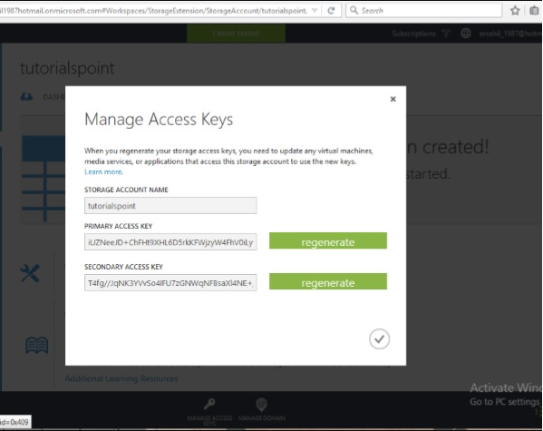

Regenerating the key at regular intervals is advised for security reasons.

## Managing Data to Azure Storage

How can you upload or download data to Azure store? There are many ways to do it, but it can’t be done within the Azure portal itself. You will have to either create your own application or use an already built tool.

There are many tools available for accessing the data in an explorer that can be accessed by clicking on ‘Storage Explorer’ under ‘Get the Tools’ in your Azure storage account. Alternatively, an application can also be built using Software Development Kit (SDK) available in Windows Azure Portal. Using the PowerShell commands is also an option to upload data. PowerShell is a command line application that facilitates administering and managing the Azure storage. Preset commands are used for different tasks to manage the storage.

You can install PowerShell by going to ‘Downloads’ on the following screen in your account. You will find it under Command-Line tools.

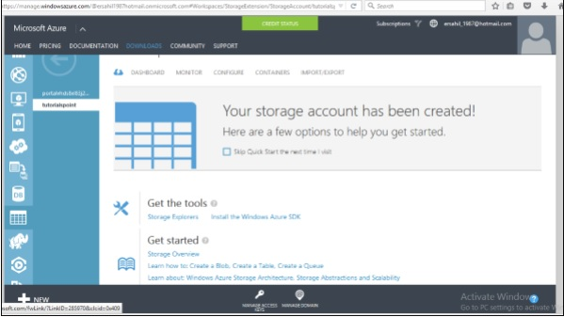

There are specific commands for each task. You can manage you storage account, create a new account, and create a container. Additionally, blobs, tables, queues messages can also be managed using PowerShell.

# Azure - Blobs

Let us first understand what a Blob is. The word ‘Blob’ expands to **B**inary **L**arge **OB**ject. Blobs include images, text files, videos and audios. There are three types of blobs in the service offered by Windows Azure namely block, append and page blobs.

* **Block blobs** are collection of individual blocks with unique block ID. The block blobs allow the users to upload large amount of data.
* **Append blobs** are optimized blocks that helps in making the operations efficient.
* **Page blobs** are compilation of pages. They allow random read and write operations. While creating a blob, if the type is not specified they are set to block type by default.

All the blobs must be inside a container in your storage. Here is how to create a container in Azure storage.

## Create a Container

**Step 1** − Go to Azure portal and then in your storage account.

**Step 2** − Create a container by clicking ‘Create new container’ as shown in following image.

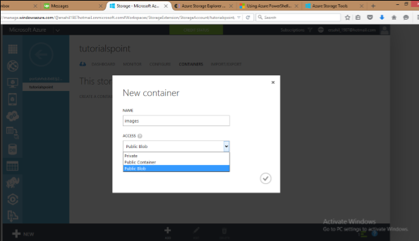

There are three options in the Access dropdown which sets the permission of who can access the blobs. ‘Private’ option will let only the account owner to access it. ‘Public Container’ will allow anonymous access to all the contents of that container. ‘Public blob’ option will set open access to blob but won’t allow access to the container.

## Upload a Blob using PowerShell

**Step 1** − Go to ‘Windows PowerShell’ in the taskbar and right-click. Choose ‘Run ISE as Administrator’.

**Step 2** − Following command will let you access your account. You have to change the fields highlighted in all the commands.

$context = New-AzureStorageContext -StorageAccountName tutorials StorageAccountKey

iUZNeeJD+ChFHt9XHL6D5rkKFWjzyW4FhV0iLyvweDi+Xtzfy76juPzJ+mWtDmbqCWjsu/nr+1pqBJj rdOO2+A==

**Step 3** − Run the following command. This will get you the details of you Azure account. This will make sure that your subscription is all set.

Get-AzureSubscription

**Step 4** − Run the following command to upload your file.

Set-AzureStorageBlobContent -Blob Montiorlog.png -Container images -File

"E:\MyPictures\MonitorLog.png" -Context $context -Force

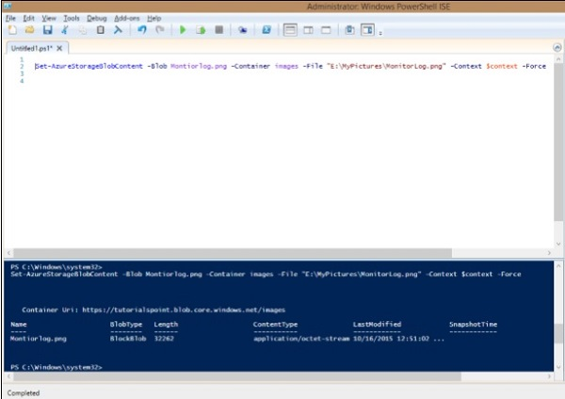

**Step 5** − To check if the file is uploaded, run the following command.

Get-AzureStorageBlob -Container $ContainerName -Context $ctx | Select Name

## Download a Blob

**Step 1** − Set the directory where you want to download the file.

$localTargetDirectory = "C:\Users\Sahil\Downloads"

**Step 2** − Download it.

$BlobName = "Montiorlog.png" Get-AzureStorageBlobContent -Blob $BlobName

Container $ContainerName -Destination $localTargetDirectory -Context $ctx

Remember the following −

* All command names and file names are case sensitive.
* Commands should be in one line or should be continued in the next line by appending ` in the preceding line (`is continuation character in PowerShell)

## Manage Blobs using Azure Storage Explorer

Managing blobs is pretty simple using ‘Azure Storage Explorer’ interface as it is just like Windows files and folder explorer. You can create a new container, upload blobs, see them in a listed format, and download them. Moreover, you can copy them to a secondary location in a very simple manner with this interface. The following image makes the process clear. As can be seen, once an account is added, we can select it from the dropdown and get going. It makes operating Azure storage very easy.

